IMAT2207 Agile Team Development
Practical – Unit 3a

Creating a Local Database
Configuring the database

Linking to the Database 1
Before you Begin 1
How this will work – Copy and Adapt 1
Managing your Database 1
Creating the Folder Structure for your Database 1
Creating Tables 5
Assigning Primary Keys 7
Adding Data to the Table 11
Creating Stored Procedures 11
Testing the Stored Procedure 13

Linking to the Database
If you are resitting the module or have a deferral you will need to use a local database instead of a shared SQL Server database.
The main advantage to you as a student is that you don’t need an internet connection to use it and it is easy to do within Visual Studio.
The main advantage for us when we’re marking your work is that we don’t need access to a user name or password.
The instructions in this handout should be used instead of the original ‘Connecting to the Database’ handout.

Before you Begin
Make sure that you have completed the work for last week.

How this will work – Copy and Adapt
In these notes I will present you with examples of what your code might look like. I will typically use the example of creating an Address Book. You are likely to be working on something quite different though. For instance, if you are working on the stock part of your system you will need to adapt my examples such that they work for you. Do not simply copy my examples as they stand!

Managing your Database
There are three different systems we need to configure in order to access your database, they are:
- Visual Studio – for creating and managing tables, stored procedures
- Data Connection Class – allowing your code to access the functionality provided by your stored procedures
- SQL Connect – a program to manage authentication of a secure connection
In this handout we will show you how to the create a table, add some data and create your first stored procedure. We’ll cover the Data Connection Class and SQL Connect in a later handout.

Creating the Folder Structure for your Database
To create the local database file, you need to create a folder that is not part of your Skeleton System project folder structure.
It doesn’t matter where you create your database, but it needs to be separate from any code going through GitHub.
Create your folder (with an informative name) and make a note of where it is for future reference. Your H:drive would be the most sensible place.
Once you have created a folder open your project in Visual Studio.
For this configuration you will be using the ‘Server Explorer’…
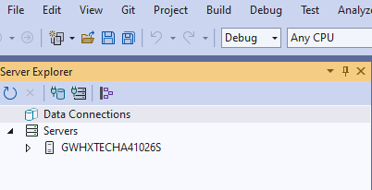

If you cannot see it go to View on the main menu and select ‘Server Explorer’ from the list to make it visible…
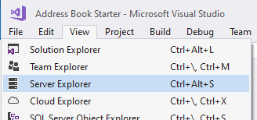

Click on the button ‘Connect to Database’.

You should now see the following screen. Make sure the Data source is the same as below. If it isn’t, click the Change button and select the correct source from the list displayed then click on the ‘Browse’ button.
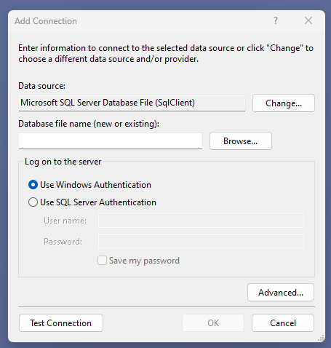
And a new window will open…
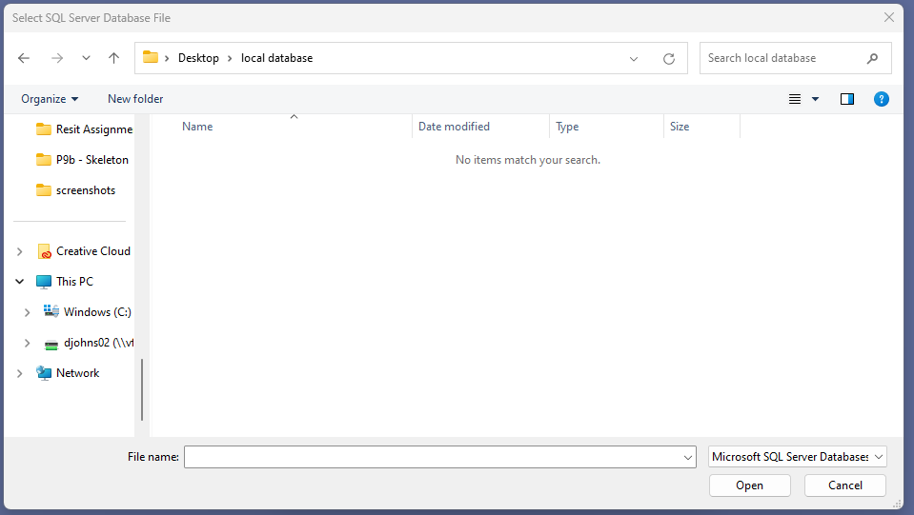
Navigate to the empty folder you created earlier to store your local database in.
In the File Name text box type the name of the database file you want to create, in my case AddressBook.mdf and then click the ‘Open’ button.

On the next window that opens click the OK button…
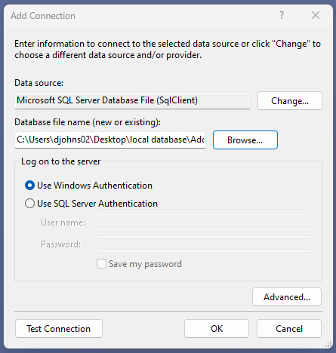
As the database doesn’t yet exist, you’ll see a pop-up window asking if you want to create the database. Click Yes…
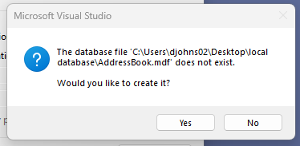

You should now be able to access the database you just created via the Server Explorer…
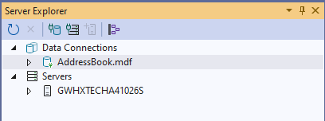
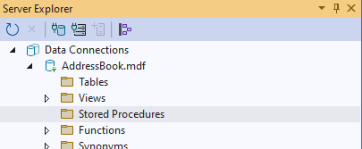
At this stage expand the sections for ‘Tables’ along with ‘Stored Procedures’. These will currently be empty and will be populated with your own tables and stored procedures as you work through the practical handouts.

Creating Tables
The next resource we need to create is a table to store some data in.
When you create your table, it will be based on the table scheme you submitted in the system specification.
From the Server Explorer, right click on the folder named ‘Tables’ and select ‘Add New Table’…
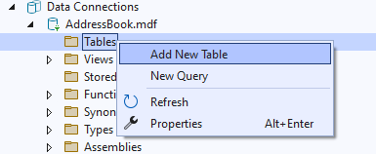

After a bit of waiting, you will be presented with the following screen...
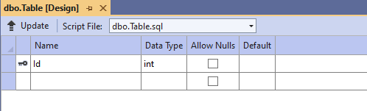
We will set up a basic table to store our addresses.
First, set the name of the table by modifying the SQL at the bottom of the window and setting the table name to tblAddress...
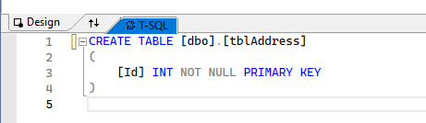
Note the “tbl” before Address: this is just to remind us that this is a table when writing select statements.
The next step is to create the fields for the table in the top section like so...
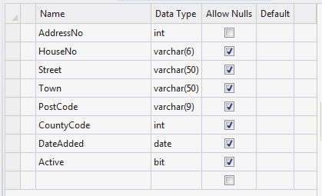
The column called ‘Name’ identifies the name of the data stored in the field (attribute). The column called ‘Data Type’ identifies what sort of data we are allowed to store in that field.

For example:

- Int - short for Integer meaning whole numbers. E.g. 1,2,3,-40, 100 NOT 4.5, 55.8 as these are decimal numbers.
- Varchar(6) - Any combination of letters or numbers up to 6 characters
- Date - Any valid data
- Bit - True or False only (Boolean)

When creating field names, it is always a good idea to consider the following:
- Avoid spaces AddressNo is better than Address No
- Avoid unusual characters # ~ !
- Use pascal naming convention AddressNo clearer than addressno
- Avoid certain reserved words date, password (+ others)

Assigning Primary Keys
Now that the fields have been set up, we need to do two more things.
The field AddressNo is going to be the primary key for this table and will be used to uniquely identify each record in the table.
The first step is to make sure this value is unique. To do this we set it as the identity of the table so that the database will generate this value.
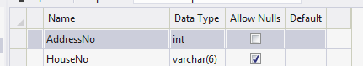
Click once in the name of the field to select it...

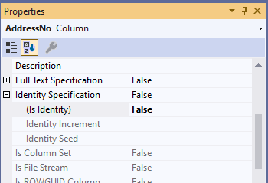

In the bottom, right hand corner of the screen are the properties for the field.
Click the ordering button so that the properties are displayed in ascending order…

Scroll down and find the property called Identity Specification and expand it...

Change “Is Identity” from False to True like so...
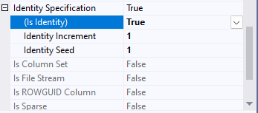
This has set the field such it starts at 1 (identity seed) and for every new record the numeric value increases by 1 (identity increment).

The last step is to set this field as the Primary Key for this table.
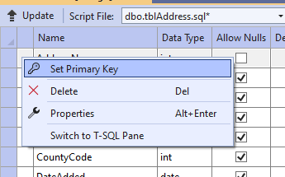
Right click to the left of the field name and select Set Primary Key...

The definition for the table should now look something like this:
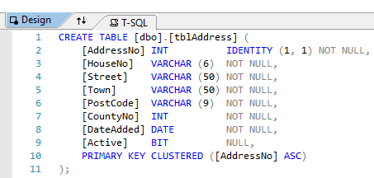

If it doesn’t, follow the next steps and once you’ve updated the database the changes will be visible.

Now that the code to create the table is set up, we need to create the table.
In Visual Studio press the button that says Update:
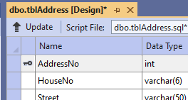

After a second or two the following screen should appear...
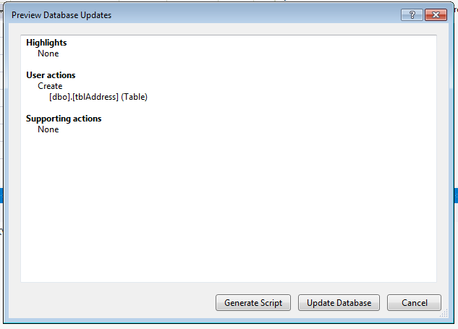
To create the new table, press Update Database.
If you get an error message or the Update Database button remains greyed out check you have completed the previous steps correctly and try again.
Note: if you don’t update the database and you open your database at a later date your table or any changes you made will be lost and you’ll have to add the new table again. Always update the database when making changes or adding new tables or stored procedures.
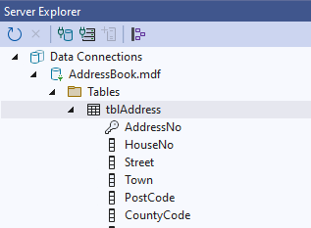
Your table should now be visible in the server explorer…

If it doesn’t appear, right click on the Tables folder and select Refresh.
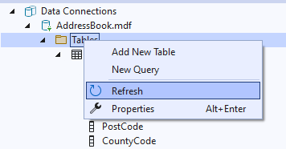

Adding Data to the Table
The next step is to add some data to your table to make sure it is working.
In the Server Explorer, right click on the name of the table and select ‘Show Table Data’.
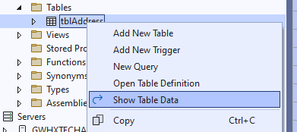
This will give you a screen allowing you to add new data to the table. Add data for each field and press the enter key on the once you’ve added data to the last field.
Notice as you add the data the value for the AddressNo field is updated automatically by the database...
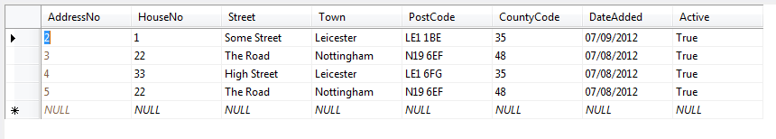
Add a few records so that we have some data for the next stage of the work.

Creating Stored Procedures
We will not be accessing the table directly with our code but using a stored procedure. One of the biggest advantages of this approach is that of increased security.

Creating a stored procedure is a very similar process to creating a table.
Right click on the ‘Stored Procedure’ folder and select ‘Add New Stored Procedure...’

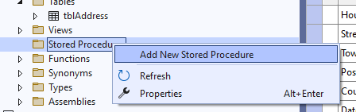

After a little while you should see the following screen appear...
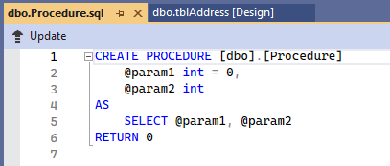
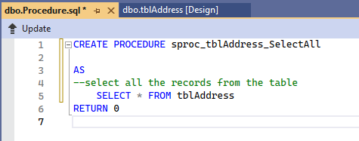
Modify the SQL code as follows...

As in the case of adding the table you must press ‘Update’ to make the changes to the database structure and then ‘Update Database’ when the pop-up window appears…

You should see the stored procedure in the tree structure of the database, if not try refreshing it...
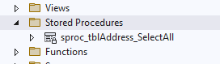
Refresh the folder if it doesn’t appear.

Testing the Stored Procedure
To make sure the stored procedure is working OK, right click on it like so and select ‘Execute…’
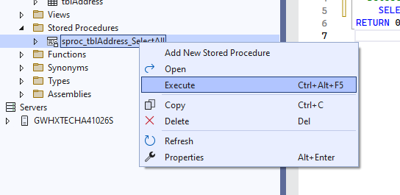
You should see the data from the underlying table displayed.
Close the query output window without saving it.
If you don’t see any data, revisit and check the stored procedure and execute it again.

